16. Develop a C program for implementing random access file for processing the employee details
#include <stdio.h>
#include <stdlib.h>

struct Employee {
int empId;
char empName[50];
float empSalary;
};

int main() {
FILE *filePtr;
struct Employee emp;
int choice;

// Open file in read/write binary mode
filePtr = fopen("employee.dat", "rb+");

// If file doesn't exist, create it
if (filePtr == NULL) {
filePtr = fopen("employee.dat", "wb+");
if (filePtr == NULL) {
printf("Error creating the file.\n");
return 1;
}
}

do {
printf("\n--- Employee Database Menu ---\n");
printf("1. Add Employee\n");
printf("2. Display Employee Details\n");
printf("3. Update Employee Details\n");
printf("4. Exit\n");
printf("Enter your choice: ");
scanf("%d", &choice);

switch (choice) {
case 1:
printf("Enter Employee ID: ");
scanf("%d", &emp.empId);
printf("Enter Employee Name: ");
scanf("%s", emp.empName);
printf("Enter Employee Salary: ");
scanf("%f", &emp.empSalary);

// Move file pointer to the specific record position
fseek(filePtr, (emp.empId - 1) * sizeof(struct Employee), SEEK_SET);
fwrite(&emp, sizeof(struct Employee), 1, filePtr);
printf("Employee details added successfully.\n");
break;

case 2:
printf("Enter Employee ID to display: ");
scanf("%d", &emp.empId);

fseek(filePtr, (emp.empId - 1) * sizeof(struct Employee), SEEK_SET);
// Read from file and check if read was successful
if (fread(&emp, sizeof(struct Employee), 1, filePtr) > 0) {
printf("\nEmployee Details:\n");
printf("ID: %d\nName: %s\nSalary: %.2f\n", emp.empId, emp.empName, emp.empSalary);
} else {
printf("Employee record not found.\n");
}
break;

case 3:
printf("Enter Employee ID to update: ");
scanf("%d", &emp.empId);

fseek(filePtr, (emp.empId - 1) * sizeof(struct Employee), SEEK_SET);
if (fread(&emp, sizeof(struct Employee), 1, filePtr) > 0) {
printf("Updating details for ID %d:\n", emp.empId);
printf("Enter New Name: ");
scanf("%s", emp.empName);
printf("Enter New Salary: ");
scanf("%f", &emp.empSalary);

fseek(filePtr, (emp.empId - 1) * sizeof(struct Employee), SEEK_SET);
fwrite(&emp, sizeof(struct Employee), 1, filePtr);
printf("Employee details updated successfully.\n");
} else {
printf("Employee record not found.\n");
}
break;

case 4:
printf("Exiting program.\n");
break;

default:
printf("Invalid choice. Please try again.\n");
}
} while (choice != 4);

fclose(filePtr);
return 0;
}
output
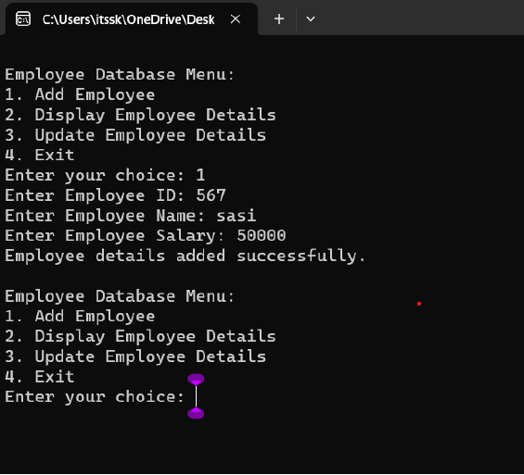

17. Illustrate the deadlock avoidance concept by simulating Banker’s algorithm using C.

#include <stdio.h>
#include <stdlib.h>

#define MAX_PROCESSES 5
#define MAX_RESOURCES 3

// Global matrices
int available[MAX_RESOURCES] = {3, 3, 2};
int maximum[MAX_PROCESSES][MAX_RESOURCES] = {
{7, 5, 3},
{3, 2, 2},
{9, 0, 2},
{2, 2, 2},
{4, 3, 3}
};
int allocation[MAX_PROCESSES][MAX_RESOURCES] = {
{0, 1, 0},
{2, 0, 0},
{3, 0, 2},
{2, 1, 1},
{0, 0, 2}
};

int is_safe();

int request_resources(int process_num, int request[]) {
// 1. Check if request <= need (maximum - allocation)
// and if request <= available
for (int i = 0; i < MAX_RESOURCES; i++) {
if (request[i] > (maximum[process_num][i] - allocation[process_num][i]) ||
request[i] > available[i]) {
return 0; // Request denied
}
}

// 2. Temporarily allocate resources
for (int i = 0; i < MAX_RESOURCES; i++) {
available[i] -= request[i];
allocation[process_num][i] += request[i];
maximum[process_num][i] -= request[i];
}

// 3. Check if system is in a safe state
if (is_safe()) {
return 1; // Request granted
} else {
// 4. Roll back changes if not safe
for (int i = 0; i < MAX_RESOURCES; i++) {
available[i] += request[i];
allocation[process_num][i] -= request[i];
maximum[process_num][i] += request[i];
}
return 0; // Request denied
}
}

int is_safe() {
int work[MAX_RESOURCES];
int finish[MAX_PROCESSES] = {0};

for (int i = 0; i < MAX_RESOURCES; i++) {
work[i] = available[i];
}

int count = 0;
while (count < MAX_PROCESSES) {
int found = 0;
for (int i = 0; i < MAX_PROCESSES; i++) {
if (finish[i] == 0) {
int j;
for (j = 0; j < MAX_RESOURCES; j++) {
// Check if Need <= Work
if ((maximum[i][j] - allocation[i][j]) > work[j]) {
break;
}
}

if (j == MAX_RESOURCES) {
// Process can finish, update work
for (int k = 0; k < MAX_RESOURCES; k++) {
work[k] += allocation[i][k];
}
finish[i] = 1;
found = 1;
count++;
}
}
}
if (found == 0) {
return 0; // Not a safe state
}
}
return 1; // Safe state
}

int main() {
int process_num, request[MAX_RESOURCES];

printf("Enter process number (0 to 4): ");
scanf("%d", &process_num);

printf("Enter resource request (e.g., 1 0 0): ");
for (int i = 0; i < MAX_RESOURCES; i++) {
scanf("%d", &request[i]);
}

if (request_resources(process_num, request)) {
printf("Request granted. System remains in a safe state.\n");
} else {
printf("Request denied. System would enter an unsafe state.\n");
}

return 0;
}

Output
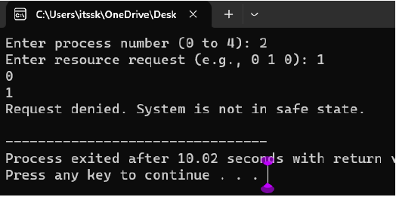

18. Construct a C program to simulate producer consumer problem using semaphores.
#include <stdio.h>
#include <stdlib.h>
#include <pthread.h>
#include <semaphore.h>
#include <unistd.h> // For sleep()

#define BUFFER_SIZE 5
#define MAX_ITEMS 10

int buffer[BUFFER_SIZE];
sem_t empty, full;
int produced_items = 0, consumed_items = 0;

void* producer(void* arg) {
while (produced_items < MAX_ITEMS) {
sem_wait(&empty); // Wait if buffer is full

// Critical section: add item to buffer
for (int i = 0; i < BUFFER_SIZE; ++i) {
if (buffer[i] == 0) {
buffer[i] = produced_items + 1;
printf("Produced: %d\n", buffer[i]);
produced_items++;
break;
}
}

sem_post(&full); // Signal that buffer has a new item
sleep(1);
}
return NULL;
}

void* consumer(void* arg) {
while (consumed_items < MAX_ITEMS) {
sem_wait(&full); // Wait if buffer is empty

// Critical section: remove item from buffer
for (int i = 0; i < BUFFER_SIZE; ++i) {
if (buffer[i] != 0) {
printf("Consumed: %d\n", buffer[i]);
buffer[i] = 0;
consumed_items++;
break;
}
}

sem_post(&empty); // Signal that a slot is now free
sleep(2);
}
return NULL;
}

int main() {
pthread_t producer_thread, consumer_thread;

// Initialize semaphores
sem_init(&empty, 0, BUFFER_SIZE); // Initial empty slots: 5
sem_init(&full, 0, 0); // Initial full slots: 0

// Create threads
pthread_create(&producer_thread, NULL, producer, NULL);
pthread_create(&consumer_thread, NULL, consumer, NULL);

// Join threads
pthread_join(producer_thread, NULL);
pthread_join(consumer_thread, NULL);

// Cleanup
sem_destroy(&empty);
sem_destroy(&full);

return 0;
}

Output
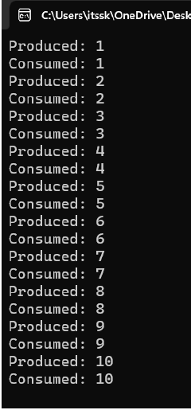

19. esign a C program to implement process synchronization using mutex locks.

#include <stdio.h>
#include <stdlib.h>
#include <pthread.h>

// Shared variable
int counter = 0;
pthread_mutex_t mutex;

// Function to be executed by threads
void *threadFunction(void *arg) {
int i;
for (i = 0; i < 1000000; ++i) {
// Lock the mutex before accessing the shared variable
pthread_mutex_lock(&mutex);

// Critical Section
counter++;

// Unlock the mutex after modification
pthread_mutex_unlock(&mutex);
}
return NULL;
}

int main() {
pthread_t thread1, thread2;

// Initialize the mutex
pthread_mutex_init(&mutex, NULL);

// Create threads
pthread_create(&thread1, NULL, threadFunction, NULL);
pthread_create(&thread2, NULL, threadFunction, NULL);

// Wait for the threads to finish
pthread_join(thread1, NULL);
pthread_join(thread2, NULL);

// Destroy the mutex
pthread_mutex_destroy(&mutex);

// Print the final value
printf("Final counter value: %d\n", counter);

return 0;
}

Output

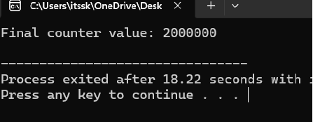

20. Construct a C program to simulate Reader-Writer problem using semaphores

#include <stdio.h>
#include <pthread.h>
#include <semaphore.h>
#include <unistd.h>

// Shared resources
sem_t mutex, writeBlock;
int data = 0;
int readersCount = 0;

void *reader(void *arg) {
int f = *((int *)arg);
for(int i = 0; i < 3; i++) {
// Entry Section
sem_wait(&mutex);
readersCount++;
if (readersCount == 1) {
sem_wait(&writeBlock); // First reader blocks the writer
}
sem_post(&mutex);

// Reading Operation
printf("Reader %d reads data: %d\n", f, data);
sleep(1); // Simulate time spent reading

// Exit Section
sem_wait(&mutex);
readersCount--;
if (readersCount == 0) {
sem_post(&writeBlock); // Last reader wakes up the writer
}
sem_post(&mutex);
sleep(1);
}
return NULL;
}

void *writer(void *arg) {
int f = *((int *)arg);
for(int i = 0; i < 3; i++) {
// Entry Section
sem_wait(&writeBlock); // Writer gets exclusive access

// Writing Operation
data++;
printf("Writer %d writes data: %d\n", f, data);
sleep(1); // Simulate time spent writing

// Exit Section
sem_post(&writeBlock);
sleep(1);
}
return NULL;
}

int main() {
pthread_t r[3], w[2];
int ids[3] = {1, 2, 3};

sem_init(&mutex, 0, 1);
sem_init(&writeBlock, 0, 1);

// Creating 3 Reader threads and 2 Writer threads
for(int i = 0; i < 3; i++) pthread_create(&r[i], NULL, reader, &ids[i]);
for(int i = 0; i < 2; i++) pthread_create(&w[i], NULL, writer, &ids[i]);

for(int i = 0; i < 3; i++) pthread_join(r[i], NULL);
for(int i = 0; i < 2; i++) pthread_join(w[i], NULL);

sem_destroy(&mutex);
sem_destroy(&writeBlock);

return 0;
}

Output

